**Daniel Johnson**

**A53072130**

**BGGN213 2019 Midterm “Find a Gene Project”**

**[Q1]Protein Name**

Protein Name: **CBFA2T1** (Product of *RUNX1T1* Gene)

Species: **Human**

Accession: **NX_Q06455**

**[Q2] Blast Search Results**

**Blast Input:**

>sp|Q06455|MTG8_HUMAN Protein **CBFA2T1** OS=**Homo sapiens** OX=9606 GN=**RUNX1T1** PE=1 SV=2

MISVKRNTWRALSLVIGDCRKKGNFEYCQDRTEKHSTMPDSPVDVKTQSRLTPPTMPPPP

TTQGAPRTSSFTPTTLTNGTSHSPTALNGAPSPPNGFSNGPSSSSSSSLANQQLPPACGA

RQLSKLKRFLTTLQQFGNDISPEIGERVRTLVLGLVNSTLTIEEFHSKLQEATNFPLRPF

VIPFLKANLPLLQRELLHCARLAKQNPAQYLAQHEQLLLDASTTSPVDSSELLLDVNENG

KRRTPDRTKENGFDREPLHSEHPSKRPCTISPGQRYSPNNGLSYQPNGLPHPTPPPPQHY

RLDDMAIAHHYRDSYRHPSHRDLRDRNRPMGLHGTRQEEMIDHRLTDREWAEEWKHLDHL

LNCIMDMVEKTRRSLTVLRRCQEADREELNYWIRRYSDAEDLKKGGGSSSSHSRQQSPVN

PDPVALDAHREFLHRPASGYVPEEIWKKAEEAVNEVKRQAMTELQKAVSEAERKAHDMIT

TERAKMERTVAEAKRQAAEDALAVINQQEDSSESCWNCGRKASETCSGCNTARYCGSFCQ

HKDWEKHHHICGQTLQAQQQGDTPAVSSSVTPNSGAGSPMDTPPAATPRSTTPGTPSTIE

TTPR

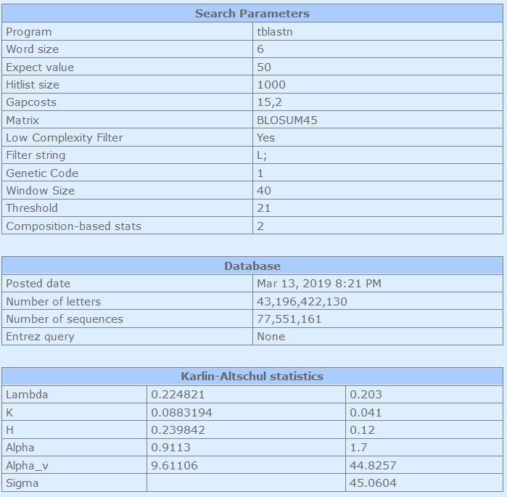

**Blast Output:**

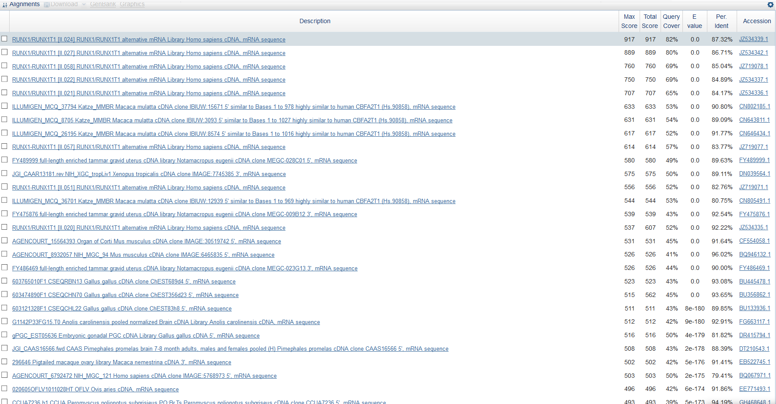

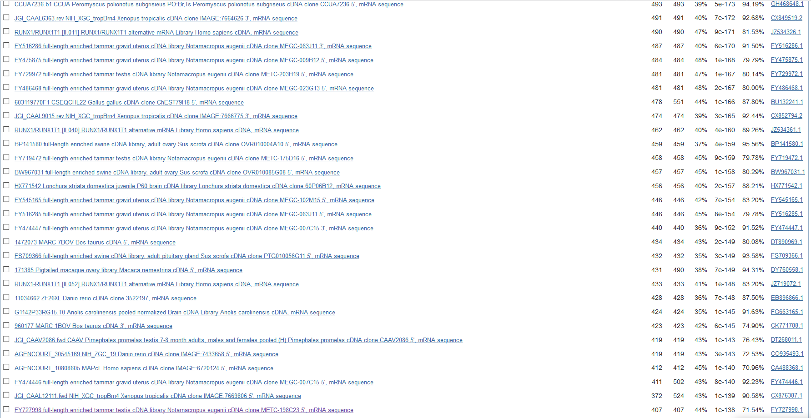

**Selected homolog:**

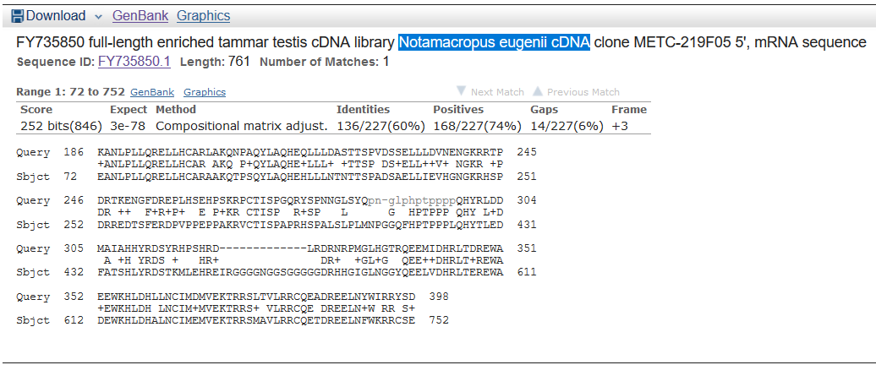

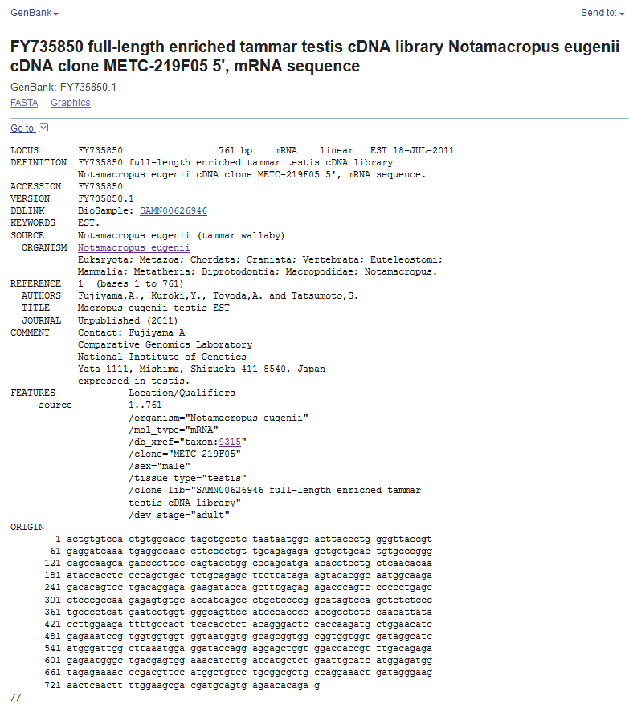

**[Q3] Novel Protein Information**

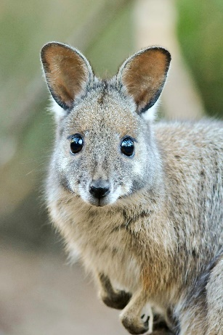Species: Notamacropus Eugenii (Tammar Wallaby)

Novel Protein Name: **CBFA2T1**

**Novel Protein Translated.**

>EMBOSS_001_Frame 1

TVSTVAPSCL**WHLPWGYREDQMRPTFPCCRESCCTVPGQPSRPLPSTWPSMNTSCSTQ

IPPPQLTLQSFL*KYTAMARDTVLTGEKIPALRETQSPLSLPPRECAPSALLPGIVQLSP

CPS*ILVGSSIPPHRLSNIIPWKILPLHTSTGTPPRCWNIEKSVVVVVMVAAVAVVVIGI

MGLA*MEDTRRSWWTTV*QRENGLTSGNILIML*IASWRW*RKPDVPWLSCGAARKLIGK

NSTFGSDDAVRTQX

>EMBOSS_001_Frame 2

LCPLWHLAASNNGTYPGVTVRIK*GQPSPVAERAAALCPGSQADPFPVPGPA*TPPAQHK

YHLPS*LCRASYRSTRQWQETQS*QERRYQL*ERPSPP*ASRQESVHHQPCSPA*SSSLP

APHESWWAVPSHPTASPTLYLGRFCHFTPLQGLHQDAGTSRNPWWWW*WWQRWRWW**AS

WDWLKWRIPGGAGGPPFDRERMG*RVETS*SCSELHHGDGRENPTFHGCPAALPGN**GR

TQLLEATMQ*EHRX

**>EMBOSS_001_Frame 3 CBFA2T1 Predicted Sequence (from EST)**

CVHCGT*LPLIMALTLGLP*GSNEANLPLLQRELLHCARAAKQTPSQYLAQHEHLLLNTN

TTSPADSAELLIEVHGNGKRHSPDRREDTSFERDPVPPEPPAKRVCTISPAPRHSPALSL

PLMNPGGQFHPTPPPLQHYTLEDFATSHLYRDSTKMLEHREIRGGGGNGGSGGGGGDRHH

GIGLNGGYQEELVDHRLTEREWADEWKHLDHALNCIMEMVEKTRRSMAVLRRCQETDREE

LNFWKRRCSENTE

>EMBOSS_001_Frame 4

LCSHCIVASKS*VLPYQFPGSAAGQPWNVGFSLPSP*CNSEHDQDVSTRQPILSLSNGGP

PAPPGILHLSQSHDAYHHHRHRCHHYHHHHGFLDVPASWWSPCRGVKWQNLPRYNVGEAV

GWDGTAHQDS*GAGRELDYAGEQG*WCTLSWREAQGGLGLSQSWYLLSCQDCVSCHCRVL

L*EALQSQLGRWYLC*AGGVHAGPGTGKGSAWLPGHSAAALSATGEGWPHLILTVTPG*V

PLLEAARCHSGHS

>EMBOSS_001_Frame 5

SVFSLHRRFQKLSSSLSVSWQRRRTAMERRVFSTISMMQFRA*SRCFHSSAHSLSVKRWS

TSSSWYPPFKPIP*CLSPPPPPLPPLPPPPRISRCSSILVESL*RCEVAKSSKV*CWRGG

GVGWNCPPGFMRGRERAGLCRGAGLMVHTLLAGGSGGTGSLSKLVSSLLSGLCLLPLPCT

SIRSSAESAGEVVFVLSRRCSCWARYWEGVCLAARAQCSSSLCNRGRLASFDPHGNPRVS

AIIRGS*VPQWTQX

>EMBOSS_001_Frame 6

LCVLTASSLPKVEFFPISFLAAPQDSHGTSGFLYHLHDAIQSMIKMFPLVSPFSLCQTVV

HQLLLVSSI*ANPMMPITTTATAATITTTTTDFSMFQHLGGVPVEV*SGKIFQGIMLERR

WGGMELPTRIHEGQGESWTMPGSRADGAHSLGGRLRGDWVSLKAGIFSPVRTVSLAIAVY

FYKKLCRVSWGGGICVEQEVFMLGQVLGRGLLGCPGTVQQLSLQQGKVGLI*SSR*PQGK

CHY*RQLGATVDTV

**[Q4]Proof of Novelty**

**>EMBOSS_001_Frame 3 CBFA2T1 Predicted Sequence (from EST)**

GSNEANLPLLQRELLHCARAAKQTPSQYLAQHEHLLLNTNTTSPADSAELLIEVHGNGKR

HSPDRREDTSFERDPVPPEPPAKRVCTISPAPRHSPALSLPLMNPGGQFHPTPPPLQHYT

LEDFATSHLYRDSTKMLEHREIRGGGGNGGSGGGGGDRHHGIGLNGGYQEELVDHRLTER

EWADEWKHLDHALNCIMEMVEKTRRSMAVLRRCQETDREELNFWKRRCSENTE

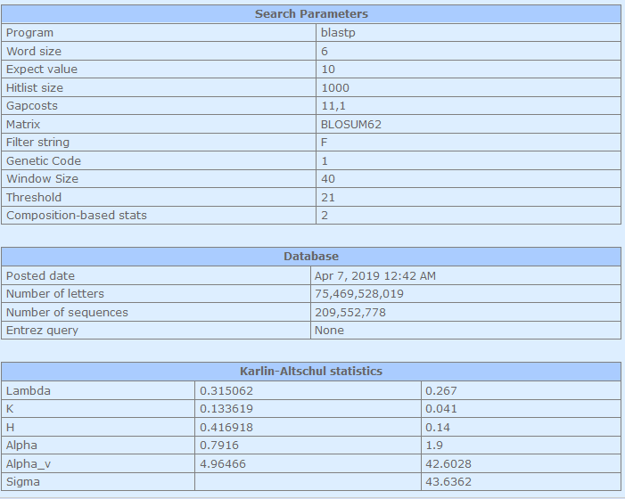

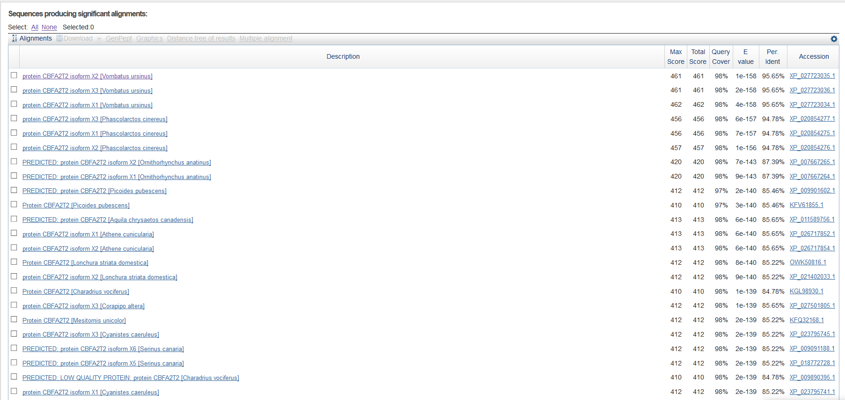

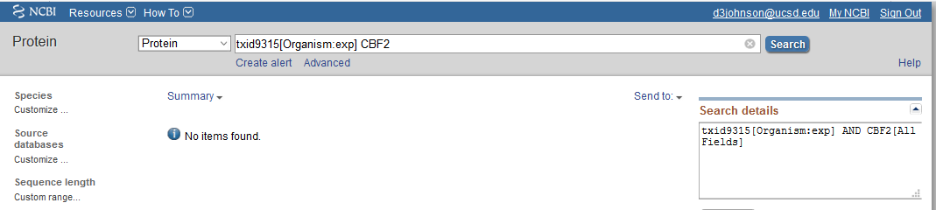

[Q5] Generate a multiple sequence alignment with your novel protein, your original query protein, and a group of other members of this family from different species. A typical number of proteins to use in a multiple sequence alignment for this assignment purpose is a minimum of 5 and a maximum of 20 - although the exact number is up to you. Include the multiple sequence alignment in your report. Use Courier font with a size appropriate to fit page width.

**CLUSTAL multiple sequence alignment by MUSCLE (3.8)**

**Human GNDISPEIGERVRTLVLGLVNSTLTIEEFHSKLQEATNFPLRPFVIPFLKANLPLLQREL**

**Orca_Whale GNDISPEIGERVRTLVLGLVNSTLTIEEFHSKLQEATNFPLRPFVIPFLKANLPLLQREL**

**Tropical_Clawed_Frog GNDISPEIGEKVRTLVLALVNSTVTIEEFHCKLQEATNFPLRPFVIPFLKANLPLLQREL**

Cow GNDISPEIGEKVRTLVLALVNSTVTIEEFHCKLQEATNFPLRPFVIPFLKANLPLLQREL

Chimpanzee GNDISPEIGEKVRTLVLALVNSTVTIEEFHCKLQEATNFPLRPFVIPFLKANLPLLQREL

Mouse GNDISPEIGEKVRTLVLALVNSTVTIEEFHCKLQEATNFPLRPFVIPFLKANLPLLQREL

**Society_Finch GNDISPEIGEKVRTLVLALVNSTVTIEEFHCKLQEATNFPLRPFVIPFLKANLPLLQREL**

**Tammar_Wallaby GSN----------------------------------------------EANLPLLQREL**

**Common_Wombat GNDISPEIGEKVRTLVLALVNSTVTIEEFHCKLQEATNFPLRPFVIPFLKANLPLLQREL**

**\*.: :\*\*\*\*\*\*\*\*\*\***

**Human LHCARLAKQNPAQYLAQHEQLLLDASTTSPVDSSELLLDVNENGKRRTPDRTKENGFDRE**

**Orca_Whale LHCARLAKQNPAQYLAQHEQLLLDASTTSPVDSSELLLDVNENGKRRTPDRTKENGFDRE**

**Tropical_Clawed_Frog LHCARAAKQTPSQYLAQHEHILLNTSTSSPADSSELLMEVNGNGKRHSPDRREENGCERE**

Cow LHCARAAKQTPSQYLAQHEHLLLNTSIASPADSSELLMEVHGNGKRPSPERREESSFERD

Chimpanzee LHCARAAKQTPSQYLAQHEHLLLNTSIASPADSSELLMEVHGNGKRPSPERREENSFDRD

Mouse LHCARAAKQTPSQYLAQHEHLLLNTSIASPADSSELLMEVHGNGKRPSPERRDENNFERD

**Society_Finch LHCARAAKQTPSQYLAQHEHILLNTNTTSPADSSELLIEVNGNGKRHSPDRREDSSFERE**

**Tammar_Wallaby LHCARAAKQTPSQYLAQHEHLLLNTNTTSPADSAELLIEVHGNGKRHSPDRREDTSFERD**

**Common_Wombat LHCARAAKQTPSQYLAQHEHLLLNTNTTSPADSAELLIEVHGNGKRHSPDRREDPSFERE**

**\*\*\*\*\* ***.*:*******::**::. :**.**:***::*: **** :*:* .: . :*:**

**Human PLHSEHPSKRPCTISPGQRYSPNNGLSY-QPNGLPHPTPPPPQHYRLDDMAIAHHYRDS-**

**Orca_Whale PLHSEHPSKRPCTISPGQRYSPNNGLSY-QPNGLPHPTPPPPQHYRLDDMAIAHHYRDS-**

**Tropical_Clawed_Frog PALPEPPVKRVCTISPAPRHSPALSLPIVNSTSHFHPTPPPLQHYSLEDIPSSQLYRDQL**

Cow AIAPEPPAKRVCTISPAPRHSPALTVPLMNPGGQFHPTPPPLQHYTLEDIATSHLYREP-

Chimpanzee TIAPEPPAKRVCTISPAPRHSPALTVPLMNPGGQFHPTPPPLQHYTLEDIATSHLYREP-

Mouse TVPPEPPAKRVCTISPAPRHSPALTVPLMNPGGQFHPTPPPLQHYTLEDIATSHLYREP-

**Society_Finch PLPTEPPAKRVCTISPAPRHSPALTIPLMNPSGQFHPTPPPLQHYTLEDIATSHLYRDP-**

**Tammar_Wallaby PVPPEPPAKRVCTISPAPRHSPALSLPLMNPGGQFHPTPPPLQHYTLEDFATSHLYRDS-**

**Common_Wombat PVPPEPPAKRVCTISPAPRHSPALSLPLMNPGGQFHPTPPPLQHYTLEDFATSHLYRDS-**

**. .* * ** *****. *:** :. :. . ****** *** *:*:. :: **:**

**Human YRHPSHRDLR-------------DRNRPMGLHG----TRQEEMIDHRLTDREWAEEWKHL**

**Orca_Whale YRHPSHRDLR-------------DRNRPMGLHG----TRQEEMIDHRLTDREWAEEWKHL**

**Tropical_Clawed_Frog SKIAEHRDIR-------------DRHHSSGVNGNLNNGYQEELVDHRLTEREWAEEWKHL**

Cow SKMIEHREVR-------------DRHHNLSLNG----GYQDELVDHRLTEREWADEWKHL

Chimpanzee NKMLEHREVR-------------DRHHSLGLNG----GYQDELVDHRLTEREWADEWKHL

Mouse NKMLEHREVR-------------ERHHNLSLNG----GYQDELVDHRLTEREWADEWKHL

**Society_Finch SKMLEHREIR-------------DRHSGLGLNG----GYQDELVDHRLTEREWADEWKHL**

**Tammar_Wallaby TKMLEHREIRGGGGNGGSGGGGGDRHHGIGLNG----GYQEELVDHRLTEREWADEWKHL**

**Common_Wombat TKMLEHREIRGSA--GGGGGAGGDRHHGLGLNG----GYQEELVDHRLTEREWADEWKHL**

**. .**::* :*: .::* *:*::*****:****:\*\*\*\*\***

**Human DHLLNCIMDMVEKTRRSLTVLRRCQEADREELNYWIRRYSDAED**

**Orca_Whale DHLLNCIMDMVEKTRRSLTVLRRCQEADREELNYWIRRYSDAED**

**Tropical_Clawed_Frog DHALNCIMEMVEKTRRSMAVLRRCQEVDRDELNYWKRRFNESNE**

Cow DHALNCIMEMVEKTRRSMAVLRRCQESDREELNYWKRRFNENTE

Chimpanzee DHALNCIMEMVEKTRRSMAVLRRCQESDREELNYWKRRYNENTE

Mouse DHALNCIMEMVEKTRRSMAVLRRCQESDREELNYWKRRFNENTE

**Society_Finch DHALNCIMEMVEKTRRSMAVLRRCQEADREELNYWKRRCSETAE**

**Tammar_Wallaby DHALNCIMEMVEKTRRSMAVLRRCQETDREELNFWKRRCSENTE**

**Common_Wombat DHALNCIMEMVEKTRRSMAVLRRCQETDREELNFWKRRCSENTE**

** *****:********::******* **:***:* ** .: :

**\*Note: I trimmed the alignment to match the coding region contained in the Wallaby EST data. Also, the Orca matches the Human perfectly; this is not a mistake (or at least not on my part), this is indeed the reported predicted Orca sequence. Also, I suspect the Chimp isoform numbers don’t match human, which explains the surprising phylogeny result to come!**

[Q6] Create a phylogenetic tree, using either a parsimony or distance-based approach. Bootstrapping and tree rooting are optional. Use “simple phylogeny” online from the EBI.

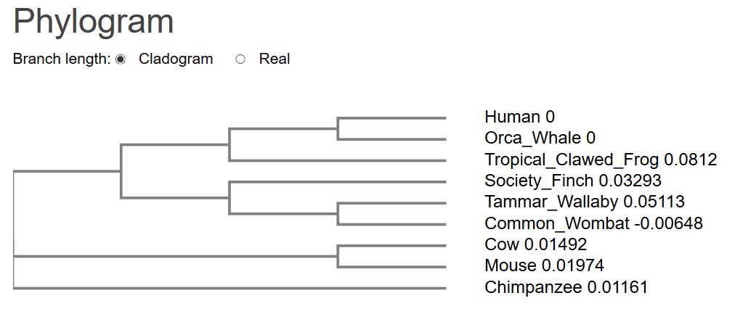

[Q7] Generate a sequence identity based heatmap of your aligned sequences using R.

[Q8] Using R/Bio3D (or an online blast server if you prefer), search the main protein structure database for the most similar atomic resolution structures to your aligned sequences. List the top 3 unique hits (i.e. not hits representing different chains from the same structure) along with their Evalue and sequence identity to your query. Please also add annotation details of these structures. For example include the annotation terms PDB identifier (structureId), Method used to solve the structure (experimentalTechnique), resolution (resolution), and source organism (source).

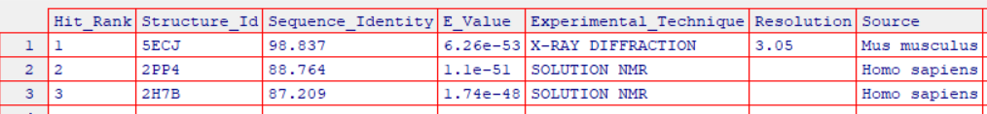

[Q9] Generate a molecular figure of one of your identified PDB structures using VMD. You can optionally highlight conserved residues that are likely to be functional. Please use a white or transparent background for your figure (i.e. not the default black).Based on sequence similarity. How likely is this structure to be similar to your “novel” protein?

5ECJ- Chains A,B,E,F. [Mouse CBFA2T2, bound to Prdm1]

This structure is extremely similar to my novel protein, CBFA2T1 consensus sequence (98.8% Identity Match, 86 residues!). Indeed, this is a structure of the CBFA2T1 family member, CBFA2T2.

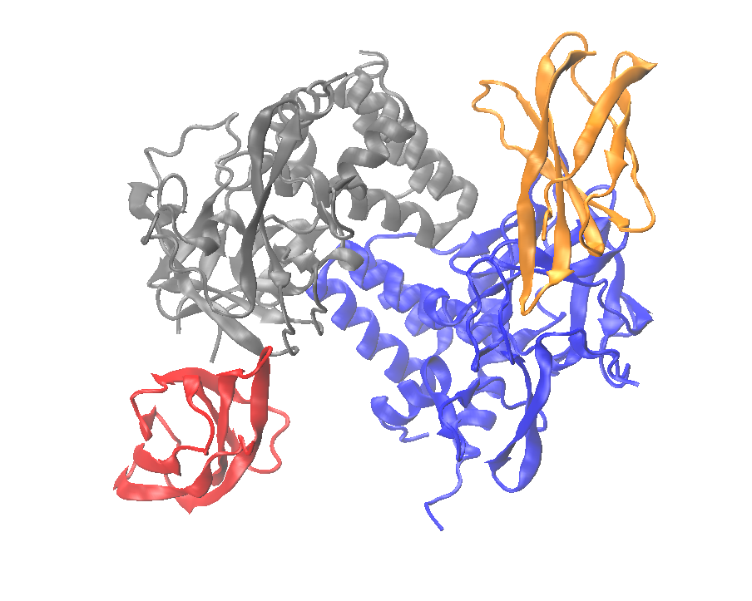

[Q10] Perform a “Target” search of ChEMBEL ( https://www.ebi.ac.uk/chembl/ ) with your novel sequence. Are there any Target Associated Assays and ligand efficiency data reported that may be useful starting points for exploring potential inhibition of your novel protein?

There are 54 Targets identified by ChEMBEL search, with many Associated assays and ligand efficiency data (too much to show!).



